

Practices for Secure Software Report

Table of Contents
Document Revision History 3
Client 3
Instructions 3
Developer 4
1. Algorithm Cipher 4
2. Certificate Generation 4
3. Deploy Cipher 4
4. Secure Communications 4
5. Secondary Testing 4
6. Functional Testing 4
7. Summary 4
8. Industry Standard Best Practices 4

Document Revision History

Version | Date | Author | Comments
1.0 | [Date] | [Your Name]

Client



Instructions

Submit this completed practices for secure software report. Replace the bracketed text with the relevant information. You must document your process for writing secure communications and refactoring code that complies with software security testing protocols.

- Respond to the steps outlined below and include your findings.
- Respond using your own words. You may also choose to include images or supporting materials. If you include them, make certain to insert them in all the relevant locations in the document.
- Refer to the Project Two Guidelines and Rubric for more detailed instructions about each section of the template.

Developer
Jose Bustamante

Algorithm Cipher

AES‑256 for encryption

SHA‑256 for hashing (checksum)

AES‑256 is widely used in industry because it provides strong encryption with a large key size that protects against brute‑force attacks. SHA‑256 is a secure hashing algorithm that produces a unique, tamper‑resistant checksum, making it ideal for verifying data integrity. These algorithms follow modern security standards and help protect sensitive information effectively.

Certificate Generation
Insert a screenshot below of the CER file.

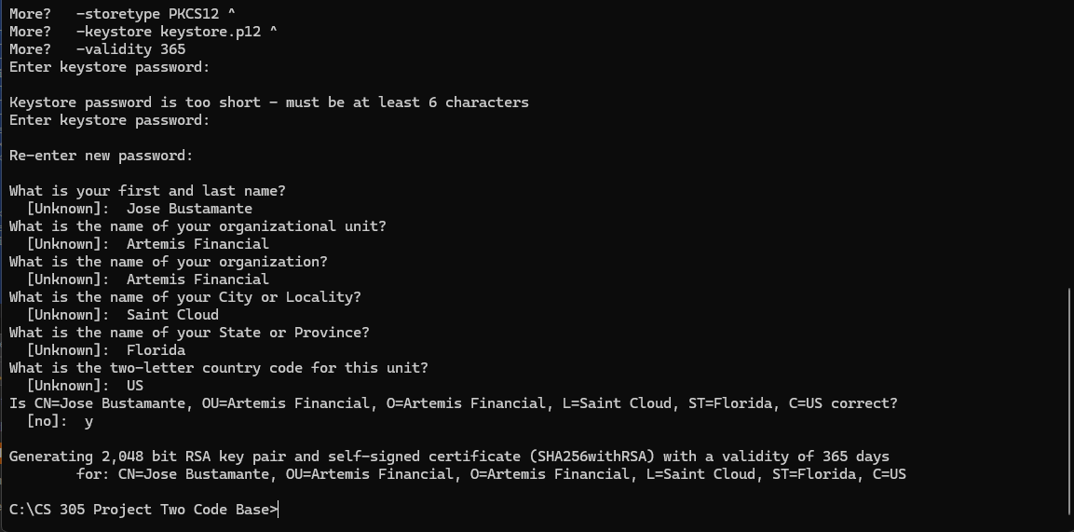

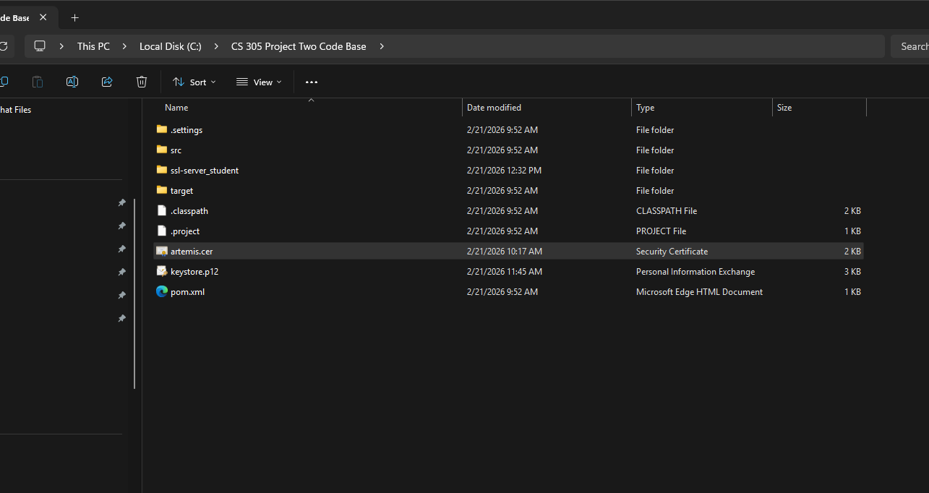

Deploy Cipher
Insert a screenshot below of the checksum verification.

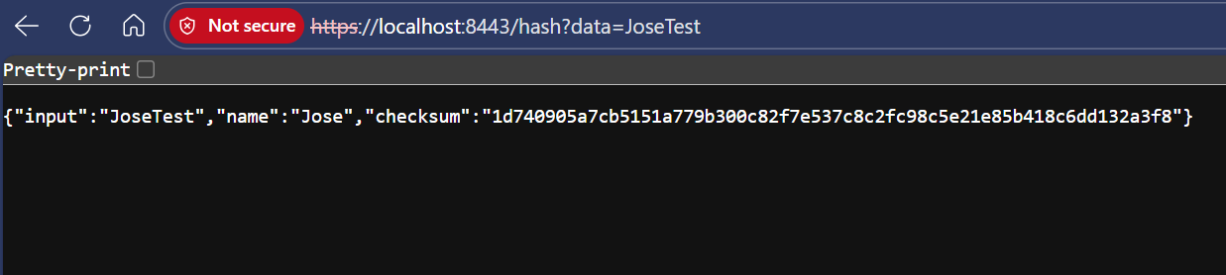

Secure Communications
Insert a screenshot below of the web browser that shows a secure webpage.

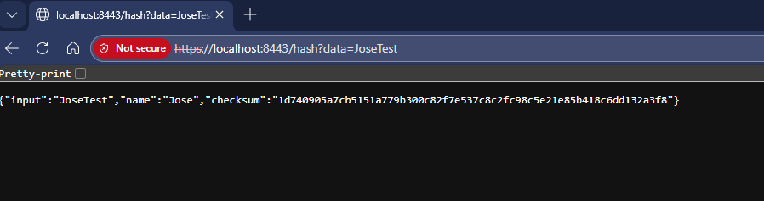

Secondary Testing
Insert screenshots below of the refactored code executed without errors and the dependency-check report.

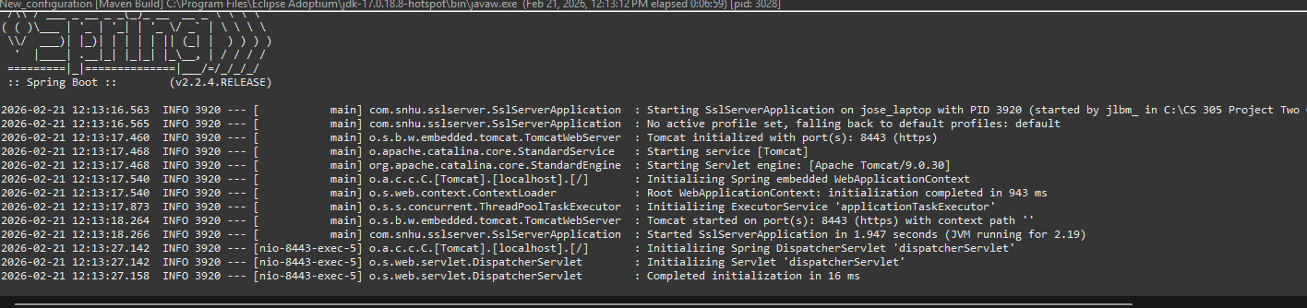
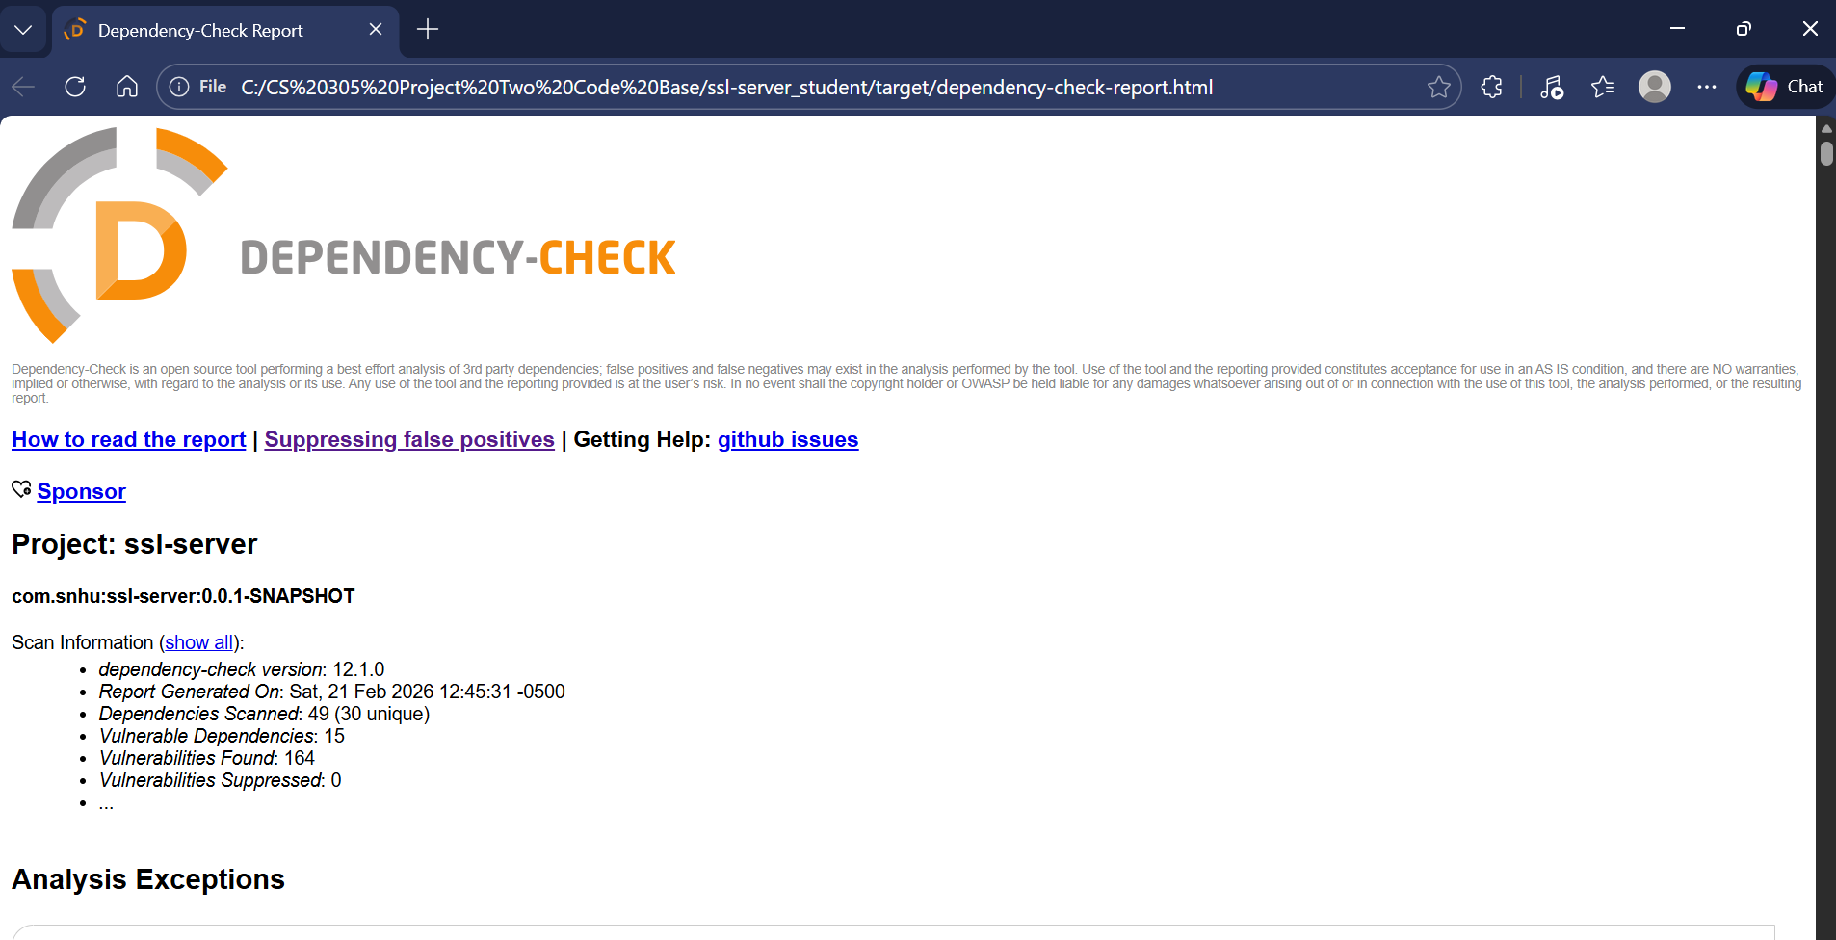

Functional Testing
Insert a screenshot below of the refactored code executed without errors.



Summary
Throughout this project, I worked step‑by‑step to build, secure, and test a Spring Boot application. I started by setting up the project and making sure the server could run correctly using HTTPS on port 8443. After that, I refactored the code, so it followed better structure and security practices, and I confirmed everything still worked by running the application without errors.

Next, I focused on improving the security of the project by using OWASP Dependency‑Check. At first, the tool failed because the older version couldn’t connect to the updated NVD database. To fix this, I upgraded the plugin to version 12.1.0 and added my NVD API key. Once updated, the tool successfully scanned all the project’s dependencies and generated a full HTML report showing which libraries had known vulnerabilities.

I also fixed additional issues by disabling the OSS Index analyzer, which was causing authorization errors. After that adjustment, the scan was completed smoothly, and the report was created without problems.

Finally, I performed functional testing to make sure the refactored application still ran correctly. The server started up cleanly, Tomcat initialized, and the application responded without any errors. This confirmed that the code changes and security updates did not break the application.

Industry Standard Best Practices

Throughout this project, I followed several industry‑standard best practices that real software teams use to build secure and reliable applications. One of the most important practices was keeping the project’s dependencies up to date and checking them for known security issues. Using tools like OWASP Dependency‑Check is a common approach in the industry because it helps developers catch vulnerabilities early before they become real risks.

Another best practice I applied for was using HTTPS instead of plain HTTP. Encrypting communication is essential for protecting data as it moves between the server and the client. Setting up SSL/TLS certificates and running the application on port 8443 shows that the project follows modern security expectations.

Refactoring the code was also part of following best practices. Clean, organized, and readable code makes the application easier to maintain and reduces the chances of bugs or security flaws. Running functional tests after refactoring is another standard practice, ensuring that changes didn’t break anything and that the application still behaves correctly.

Finally, documenting the process with screenshots and explanations mirrors how professional developers communicate their work. Clear documentation helps teams understand what was done, why it was done, and how to reproduce the results.

The steps taken in this project reflect the same habits and standards used in real‑world software development: secure coding, dependency management, testing, refactoring, and clear documentation.

